California Citrus Nursery Society
1912 Prince Albert Dr
Riverside, California 92507

February 24, 2022

Via Electronic Mail
Plant Protection and Quarantine
Animal and Plant Health Inspection Service
U.S. Department of Agriculture
PPQ.Citrus.Health@aphis.usda.gov
kathy.m.slaga@usda.gov

Subject: Survey: Interstate Movement of Citrus Nursery Stock from Areas Quarantined for Citrus Canker, Asian Citrus Psyllid, and/or Citrus Greening

Dear Sir or Madam:
The citrus Nursery industries in California appreciate this opportunity to submit comments on the November 25, 2019 protocol on the Interstate Movement of Citrus Nursery Stock from Areas Quarantined for Citrus Canker, Citrus Greening, and/or Asian Citrus Psyllid.

The following comments are a compilation from Citrus Nurserymen that are members of the California Citrus Nursery Society and from scholars from the University of California. Below you will find:
- Comments gathered during several CCNS related events held in the last two
years on page 2, 3, and part of 4.
- The comments submitted in March 2019 by CCNS, during the open comments
period on page 4, 5, 6, 7, and 8.

General Comments 2022
We appreciate the time, effort, and thought that went into producing this document.
As we stated in our March 2019 comments submission, we recognize this protocol governs the interstate movement of citrus nursery stock, but we recognize that it also governs intrastate movement in California between quarantine and non-quarantine regions of the state. We request the U.S. Department of Agriculture’s (USDA) assistance in unifying interstate and intrastate movements in California. Specifically, the protocol allows the use of safe and effective pesticide registered products that are not recognized under California regulations. Assistance from USDA in persuading California to recognize these products would allow for greater flexibility in complying with the protocol.

We also request to please take into consideration our comments submitted in March 2019 during the open comments period and our new comments below.

Specific Comments submitted in March 2022

- Paragraph I.d.ii. and Definition section on page 8.: Breach definition. The November 25, 2019, CNS protocol includes the following definition for Breach, “Any circumstance that would allow free access by federally-regulated pests into a structure, container, package or means of conveyance.” We request to update the definition in the November 25, 2019, CNS version, to match the definition reported in Section 3701 - Citrus nursery stock pest cleanliness program (California Code of Regulations) "Breach" means any detectable opening of a size approximately 0.3 square millimeters inadvertently made in an insect-resistant structure.
Justification: Nursery growers' primary goal is to produce high-quality disease-free materials. An aligned definition across regulatory protocols is vital since, based on the definition, the nursery will be better equipped to act appropriately (i.e., know right away when and if the breach occurred and when to start contacting and conveying information to the regulators).

We request clarification on what’s the appropriate response to a breach. We are requesting to revise and improve the CNS protocol to include:
- A list of actions to be taken by the growers once a breach has been identified in their facility.
- A timeline. The action items above need to be well defined and include a timeline.
Justification: We understand that every breach is different however is currently very
hard, for a citrus nursery grower, from a practical management perspective, to know
the appropriate response to a breach event. A well-defined action list and timeline
would help growers and regulators to carry out an assessment and get a
recommendation so the problem is addressed promptly and the negative impact to the nursery business minimized.

2. Paragraph I.a.ii. and V.a. Both sections cite “non-citrus producing states”, however, the CNS protocol does not include a list “non-citrus producing states”. The 2019 CNS protocol does include, in the definitions section, a list on “Commercial citrus producing states. American Samoa, Arizona, California, Florida, Guam, Hawaii, Louisiana, Northern Mariana Islands, Puerto Rico, Texas, and U.S. Virgin Islands. We request to include an updated list of “non-citrus producing states”.

3. Paragraph III.C.1.: Based on new research data and actual experience with the implementation of this protocol, we renew and adjust our request that the requirement for treatment with systemic insecticide be changed to “at least 3 days but no more than 3 months (90 days)”. NOTE: This comment was submitted by CCNS in March 2019 (Please See item 4. Specific Comments submitted in March 2019). At that time the comment was not considered because, although there were 2 scientific manuscripts published on this topic by Dr. Frank Byrne, there was an additional ongoing research project and its peer-reviewed publication had not been published yet.
Justification: The 3rd publication is now officially published. Please find all 3 published research work below. New evidence with respect to the uptake of systemic insecticides in citrus nursery stock (CNS) is very rapid. We hope that the additional evidence described below will lead to a conclusion that the optimal time for pre-shipment application of systemic insecticides is immediately prior to shipment.
Publications
- Frank J. Byrne, Matthew P. Daugherty, Elizabeth E. Grafton-Cardwell (2020). Rapid uptake and retention of neonicotinoids in nursery citrus trees as a safeguard against Asian citrus psyllid (Diaphorina citri) infestation, Crop Protection 138 (4): 105345. DOI:10.1016/j.cropro.2020.105345.
- Byrne, Grafton-Cardwell, Morse, Olguin, Zeilinger, Wilen, Bethke, Daugherty (2018). Assessing the risk of containerized citrus contributing to Asian citrus psyllid (Diaphorina citri) spread in California: Residence times and insecticide residues at retail nursery outlets. Crop Protection 109: 33-41.
- Byrne, Daugherty, Grafton-Cardwell, Bethke, Morse (2017). Evaluation of systemic neonicotinoid insecticides for the management of the Asian citrus psyllid Diaphorina citri on containerized citrus. Pest Management Science 73: 506-514.

==============================================================
General Comments submitted in March 2019

The new document represents a great improvement over the 2017 version. We appreciate the time, effort, and thought that went into producing this document.
Minor request for correction: Please update the previous version in the current webpage. The above webpage states “For reference purposes we are providing the previous version of the Citrus Nursery Stock Protocol. This version is now obsolete.” but includes the 2012 not the 2017 version.

We recognize this protocol governs interstate movement of citrus nursery stock, but we recognize that it also governs intrastate movement in California between quarantine and non-quarantine regions of the state. We request U.S. Department of Agriculture’s (USDA) assistance in unifying interstate and intrastate movement in California. Specifically, the protocol allows the use of safe and effective pesticide registered products that are not recognized under California regulations. Assistance from USDA in persuading California to recognize these products would allow for greater flexibility in complying with the protocol.

Specific Comments submitted in March 2019
1. Paragraph I.F.: Thank you for addressing our 2017 comment.
Minor correction to current document: In Paragraph I.F, please update the survey protocol year from 2017 to 2018.

2. Paragraph I.G.: We renew our request that “within a contiguous quarantine area” be removed. This paragraph requires that “safeguards are in place” for movement between approved protective structures. Such safeguards include shipping in sealed containers—filled and sealed inside a protective structure at the sending nursery and opened and unloaded inside a protective structure at the receiving nursery. A closed, sealed container provides the same high level of protection for movements between quarantine areas as it does within a quarantine area.
Overall, the following protective activities in the systems approach employed by citrus nurseries make such materials extremely low risk for transporting quarantined pests since:
a. Approved structures are inspected by USDA inspectors monthly to verify the absence of quarantined pests.
b. Citrus nursery stock (CNS) are treated with systemic pesticides prior to shipment.
c. CNS are sprayed with a foliar pesticide prior to shipment.
d. CNS are inspected by a USDA inspector prior to shipment.
e. CNS are shipped in sealed containers and/or certified trucks.
f. CNS are inspected upon arrival at the receiver’s location.
g. In California, all plants are derived from the state’s Clean Stock Program.

3. Paragraph III.B.i.: Based on practical experience with the implementation of this protocol, we would like to renew and adjust our request that the inspection interval be revised and thus the following sentence “The interval between inspections must not exceed 30 calendar days” to be replaced with “Inspections shall occur once each calendar month with no greater than 35 days between inspections.”

Justification: We understand that the intent is to have inspections once a month. The problem is that some months have more than 30 days and some months have less than 30 days. Also, inspectors don’t usually inspect during weekends or holidays.
Given that inspectors adhere to the every-30-days rule, if, for example, inspectors come March 1st, they would have to schedule the next inspection on March 31st which would result in 2 inspections in the month of March and more than 12 inspections in a calendar year. We recognize that specifying “once per month” could result in sixty days between inspections (For example inspections on March 1st and April 29th); however, if “...no greater than 35 days between inspections” were added, it would allow for a reasonable time between inspections, to allow for weekend and holidays, and result in inspections occurring with a frequency of “once a month”, while eliminating the possibility of having 60 days between inspections.

4. Paragraph III.C.ii.: Based on new research data and actual experience with the implementation of this protocol, we renew and adjust our request that the requirement for treatment with systemic insecticide be changed to “at least 3 days but no more than 3 months (90 days)”.

Also, please note the proposed changes for the insecticide chemistries proposed below in item 8 and 9 for thiamethoxam and dinotefuran.

Justification: New evidence with respect to the uptake of systemic insecticides in citrus nursery stock (CNS) is very rapid. We hope that the additional evidence described below will lead to a conclusion that the optimal time for pre-shipment application of systemic insecticides is immediately prior to shipment.

- Survey data clearly shows that citrus nursery stock (CNS) can spend a considerably long period of time awaiting sale at retail outlets. The published survey data indicated that some trees were resident at the retail outlets over 1 year. Because of this, it is essential that the protective effects of the systemic and foliar treatments that are applied at the production facilities be maximized to the fullest extent possible.
- Two studies published in peer-reviewed journals by researchers at UCR that show the temporal profiles of imidacloprid, thiamethoxam and dinotefuran in CNS. The data show that all the neonicotinoids are well-established in the trees well within 30 days of treatment, which is the current minimum pre-shipment period that APHIS requires before CNS can be shipped to retail.
- Upon request by, and with funding from APHIS, UCR researchers have generated new data on the early uptake of imidacloprid into CNS. The study evaluated 4 varieties and 4 label rates of imidacloprid. At all rates, the imidacloprid was established in the trees at concentrations above the 200 ppb threshold (required to prevent ACP colonization) within 3 days of treatment.
- The combined data shows that the current 30-day limit is excessive and could be shortened to three days without compromising protection.
- If the treatments are expected to protect the tree for 90 days, then it is important to maximize the protective effect of the treatments while the CNS is in retail. Shortening the pre-shipment interval to 3 days could add almost 4 weeks of extra time to the period of efficacy for the treatments while at retail.
- Because of the 30-day limit, many production nurseries are treating their CNS on a 90-day cycle so that they have CNS ready to ship when orders come in. This means that some CNS could conceivably be shipped from a production facility to retail when the 90-day certification period has almost elapsed, further shortening the period that trees are protected while in retail.
- Shortening the pre-shipment period to 3-days would be an incentive to producers to refrain from the cyclical treatments, and instead apply the systemic and foliar treatments at the same time (3 days before shipping). Applying the foliar treatment at the same time as the systemic provides additional protection to the trees while the systemic treatment is still increasing in concentration.
- UCR data show that thiamethoxam established in trees at effective concentrations within 3 days of application. Thiamethoxam should be added to the list of approved treatments.
- UCR data show that dinotefuran was not as effective as either imidacloprid or thiamethoxam at protecting CNS from ACP infestation, and this chemical should be removed from the list of approved treatments.
Publications
Byrne, Daugherty, Grafton-Cardwell, Bethke, Morse (2017). Evaluation of systemic neonicotinoid insecticides for the management of the Asian citrus psyllid Diaphorina citri on containerized citrus. Pest Management Science 73: 506-514.

Byrne, Grafton-Cardwell, Morse, Olguin, Zeilinger, Wilen, Bethke, Daugherty (2018). Assessing the risk of containerized citrus contributing to Asian citrus psyllid (Diaphorina citri) spread in California: Residence times and insecticide residues at retail nursery outlets. Crop Protection 109: 33-41.

Figure 1. The uptake of imidacloprid in 4 citrus varieties. Imidacloprid was applied at 4 different rates, and the residues in young leaf tissue measured over time. The target threshold for the treatments is indicated by the dashed line (ACP threshold) at 200 ppb. At all rates, the threshold was exceeded at 3 days, including when the trees were overwatered (mandarins only were used for the overwatering experiment). For the overwatering experiment, the watering is expressed in terms of % ET, where 100% ET represents optimal watering, and 400% ET represents excessive watering that results in leaching from the bottom of the pot.
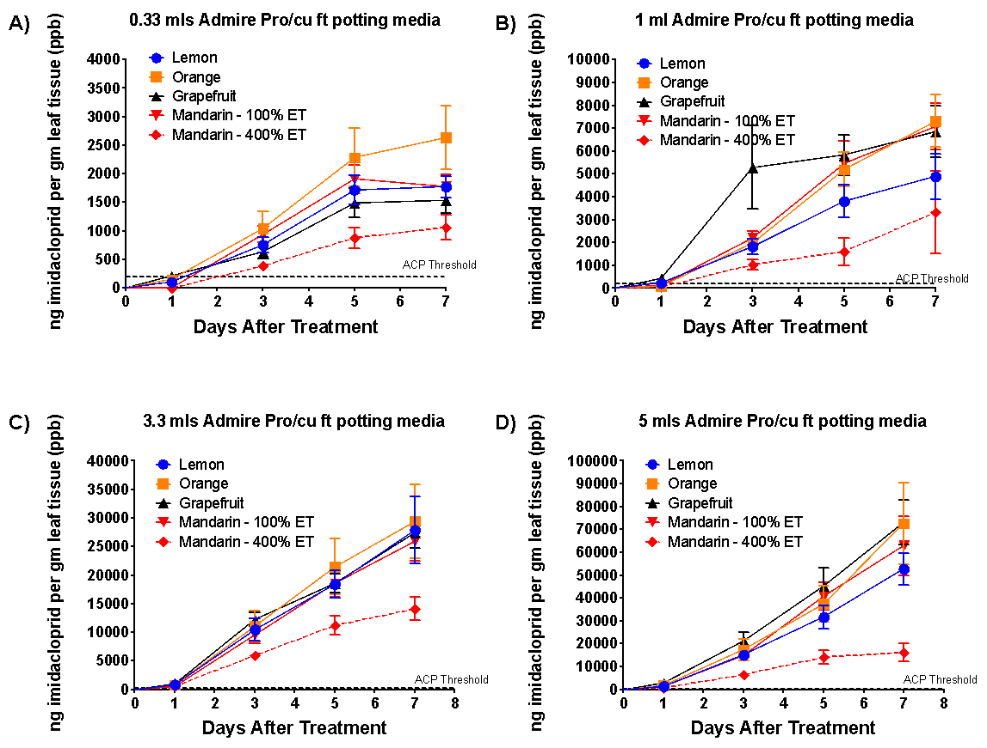

5. Paragraph IV.B.1.: We renew our request to include a reference to the Survey Protocol 2018... referenced in Paragraph I.F. We understand the reference to “methods approved by APHIS” to mean the Survey Protocol 2018…but it is important to include this reference to avoid any potential confusion.

6. Paragraph IV.B.2.: We renew our request to revise the first sentence to remove “ by a diagnostician certified by APHIS” and read as “Testing for CG must be conducted by a laboratory accredited by APHIS.” This protocol should not interfere with personnel and the standard operating procedures of USDA-APHIS accredited laboratories.

Thank you

Sincerely
CALIFORNIA CITRUS NURSERY SOCIETY

Deborah Pagliaccia
Executive Director

